https://graphlertech.com/services/prototyping-and-manufacturing/

What is injection molding ?
Injection molding is a method to obtain molded products by injecting plastic materials molten by heat into a mold, and then cooling and solidifying them.
The method is suitable for the mass production of products with complicated shapes, and takes a large part in the area of plastic processing.
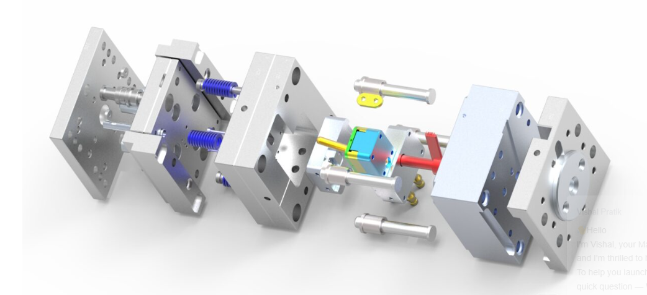
Injection molding machine
Injection molding machine is divided into 2 units i.e. a clamping unit and an injection unit.
The functions of the clamping unit are opening and closing a die, and the ejection of products. There are 2 types of clamping methods, namely the toggle type shown in the figure below and the straight-hydraulic type in which a mold is directly opened and closed with a hydraulic cylinder.
The functions of the injection unit are to melt plastic by heat and then to inject molten plastic into a mold.
The screw is rotated to melt plastic introduced from the hopper and to accumulate molten plastic in front of the screw ( to be called metering ) . After the required amount of molten plastic is accumulated, injection process is stared.
While molten plastic is flowing in a mold, the machine controls the moving speed of the screw, or injection speed. On the other hand, it controls dwell pressure after molten plastic fills out cavities.
The position of change from speed control to pressure control is set at the point where either screw position or injection pressure reaches a certain fixed value.

Mold
A mold is a hollow metal block into which molten plastic is injected to from a certain fixed shape. Although they are not illustrated in the figure shown below, actually there are many holes drilled in the block for temperature control by means of hot water, oil or heaters.
Molten plastic flows into a mold through a sprue and fills cavities by way of runners and gates. Then, the mold is opened after cooling process and the ejector rod of the injection molding machine pushes the ejector plate of the mold to further eject moldings.

Molding
A molding consists of a sprue to introduce molten resin, a runner to lead it to cavities, and products. Since obtaining only one product by one shot is very inefficient, a mold is usually designed to have multiple cavities connected with a runner so that many products can be made by one shot.
If the length of the runner to each cavity is different in this case, the cavities may not be filled simultaneously, so that dimensions, appearances or properties of the moldings are often different cavity by cavity. Therefore the runner is usually designed so as to have the same length from the sprue to each cavity.

Use of reprocessed materials
Sprues and runners among moldings are not products. These portions are sometimes discarded, but in other cases they are finely reground and reused as materials for molding. These materials are called reprocessed materials.

Reprocessed materials are not solely used as materials for molding but usually used after blending with virgin pellets, since there is possibility of deterioration in various characteristics of the plastics because of the initial molding process. The maximum allowable limit for the ratio of reprocessed materials is about 30 %, because too high ratio of reprocessed materials may spoil the original properties of the plastics used.
For the properties when reprocessed materials are used, please refer to "reprocessing capability" in the plastic data base.

Molding condition
Molding condition means cylinder temperature, injection speed, mold temperature etc. set in a molding machine to obtain required moldings, and the number of combinations of conditions is innumerable. Depending on the conditions selected, the appearances, dimensions, and mechanical properties of the molded products change considerably.
Therefore, well-tried technology and experience are required to select the most suitable molding conditions.
The standard molding conditions for our materials are shown below. Please click the mouse at the following names of plastics.

Blow molding
This process can be used to manufacture plastic products. The process involves heating a plastic tube (known as a preform or parison) to its melting point and then putting that into the cavity of a mold.
They then use compressed air to inflate the molten plastic like a balloon so that it takes the shape of the mold but is hollow inside. The amount of plastic used and the air pressure determines how thick the final product is.
Blow molding is a manufacturing process that produces hollow plastic objects using air pressure. It has several advantages, including:
- High production rates: Blow molding can produce large quantities of products in a short amount of time.
- Low tooling costs: Blow molding has low costs for tools and dies.
- Automated production: Blow molding can be automated.
- High product variety: Blow molding can produce a variety of products, including containers like milk jugs and soda bottles.
- Ability to mold complex parts: Blow molding can produce complex parts, and handles can be incorporated into the design.

Vertical molding machine

Vertical injection molding (VIM) is a production method used to produce plastic parts through vertical injection molding machines designed specifically to operate vertically. This process can be seen by clamping unit movement and injection unit injection movement – two key features of VIM that make this a successful method.
Vertical injection molding uses plastic pellets melted and injected into mold cavities to form parts, then solidifies to take shape as expected by the mold cavity. This process provides several advantages over Key advantages of a vertical molding machine:
- Enhanced accuracy and consistency:
The vertical clamping mechanism allows for better mold alignment, resulting in more precise part dimensions and consistent quality across production runs.
- Improved part quality for complex designs:
With easier access to the mold cavity, vertical machines excel at molding intricate or delicate parts with minimal defects.
- Efficient insert molding:
Insert parts can be easily inserted into the mold during the molding process due to the vertical orientation, reducing the risk of misalignment.
- Streamlined production flow:
The vertical design often allows for a more efficient workflow, especially in high-volume production scenarios.
- Greater visibility during molding:
Operators have better visual access to the mold cavity, facilitating quality checks and troubleshooting.
- Reduced material waste:
Precise control over the injection process can minimize material waste and optimize material usage.
horizontal injection molding such as increased efficiency, space saving design and versatile applications.
Roto molding

What is Roto molding process?
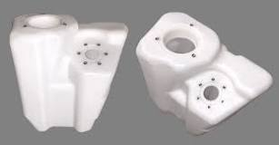
The rotational molding process is quite simple: A hollow mold is filled with powdered plastic resin. The mold begins rotating bi-axially and is transferred into an oven. The mold continues to rotate as the resin melts and coats the walls of the mold. The mold is cooled until the resin hardens into the desired shape.
- High-Quality and Durable Products: Undoubtedly, rotomolding creates high-quality and durable products due to the uniform and consistent thickness of the plastic material. The roto-molding process results in strong, resilient products resistant to damage.
- Versatile: Rotomolding produces various products, from complex industrial parts to simple toys. Fortunately, this versatility means that roto-molding is for multiple applications, including consumer goods, agriculture, and transportation.
- Cost-Effective: Certainly, rotomolding is a cost-effective plastic molding technique. The process requires minimal tooling and can produce large quantities of products in a single cycle. This results in lower costs and increased efficiency.
- Environmental Friendly: Rotomolding is an environmentally friendly plastic molding technique. The process produces minimal waste, and the products made are recyclable.
Rapid molding
Rapid injection molding method is revolutionizing how products come to life, blending efficiency and speed with engineering. This process makes it possible to manufacture many durable consumer and industrial items cheaper than everything else. It produces around 32% of plastics by weight. Rapid injection molding is a type of injection molding designed to produce parts quickly and efficiently, bridging the gap between initial prototypes and mass production. It is exceptionally suited for generating anywhere from a few units to 10,000 parts within a matter of weeks. It embodies the intersection of speed and accuracy, making it a go-to choice for companies across various industries.
AdvantageS
Rapid molding or quick molds are a great manufacturing solution for injection-molded parts that meet certain conditions.
- Parts Needed Fast. When turnaround time is essential, rapid injection molding can deliver parts quickly.
- Low Production Numbers. The overall production run will be small. Quick molds are not as durable and will not stand up to extended use. Small production runs will also help ensure delivery on an enhanced timetable.
- Design Simplicity. Rapid molding will benefit from a simplistic design. This will speed up the mold making process and help keep the project on schedule.
Quick molds can be a better option than Production Molds under the right conditions. A rapid mold can be produced faster and more economically. However, it’s also important to understand the limitations of rapid injection molding to know if this option fits your requirements.

Insert Injection Molding

Insert injection molding is the process of molding or forming plastic parts around other, non-plastic parts, or inserts. The inserted component is most commonly a simple object, such as a thread or rod, but in some cases, inserts can be as complex as a battery or motor.
Moreover, Insert Molding combines metal and plastics, or multiple combinations of materials and components into a single unit. The process makes use of engineering plastics for improved wear resistance, tensile strength and weight reduction as well as using metallic materials for strength and conductivity.

Over molding

